I know you guys might have had this question. Once the model is built, i donot have a training set to find the distances and classify the points rt?

If this is a point we want to classify.

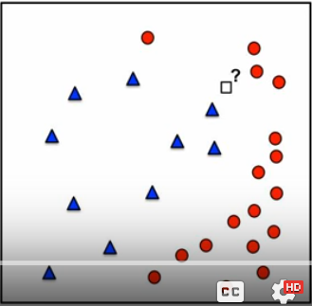

We are trying to find some nearest point using some distance function (why distance? … using distance we are computing similarities.)

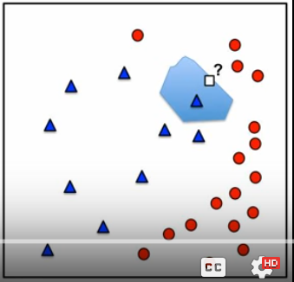

A region is created and that region is called voronoi cell for every cell in the training example.